

*[JGR-Solid Earth]*

Supporting Information for

**The crust and upper mantle structure of central and West Antarctica from Bayesian inversion of Rayleigh wave and receiver functions**

Weisen Shen1,2, Douglas Wiens1, Sridhar Anandakrishnan2, Richard C. Aster3, Peter Gerstoft4, Peter Bromirski4, Samantha E. Hansen5, Ian Dalziel6, David Heeszel7, Audrey Huerta8, Andrew Nyblade2, Ralph Stephen9, Terry Wilson10, and J. Paul Winberry8.

1 Department of Earth and Planetary Sciences, Washington University in St Louis, St Louis, MO, 63112

2 now at: Department of Geosciences, Stony Brook University, Stony Brook, NY, 11794

2 Department of Geosciences, Penn State University, PA, 16802

3 Department of Geosciences and Warner College of Natural Resources, Colorado State University, Fort Collins CO, USA, 80523

4 Scripps Institution of Oceanography, University of California, San Diego

5 Department of Geological Sciences, The University of Alabama, Tuscaloosa, AL, USA, 35487

6 Institute for Geophysics, Jackson School of Geosciences, The University of Texas at Austin, JJ Pickle Research Campus, TX, USA, 78758

7 United States Nuclear Regulatory Commission, Washington DC, USA, 20555

8 Department of Geological Sciences, Central Washington University, Ellensburg, Washington, USA

9 Woods Hole Oceanographic Institution

10 Department of Geological Sciences, Ohio State University, Columbus, Ohio, USA

**Contents of this file**

Text S1 to S4

Figures S1 to S13

**Introduction**

We provide below the supporting information for the ambient noise tomography (map views of the resolution) as well as two additional tests of the Monte Carlo inversion against different attenuation models, crustal Vp/Vs values, and crustal Vs-density relationships.

**Text S1. Ambient noise tomography**

This section provides more details of the ambient noise tomography. After collecting surface wave phase and group velocity measurements (density shown in Fig. S1), the tomography is performed at a 0.5o by 0.5o grid (Fig. S1c). To remove the singularity, we rotate the coordinate system from polar regions to the equatorial areas.

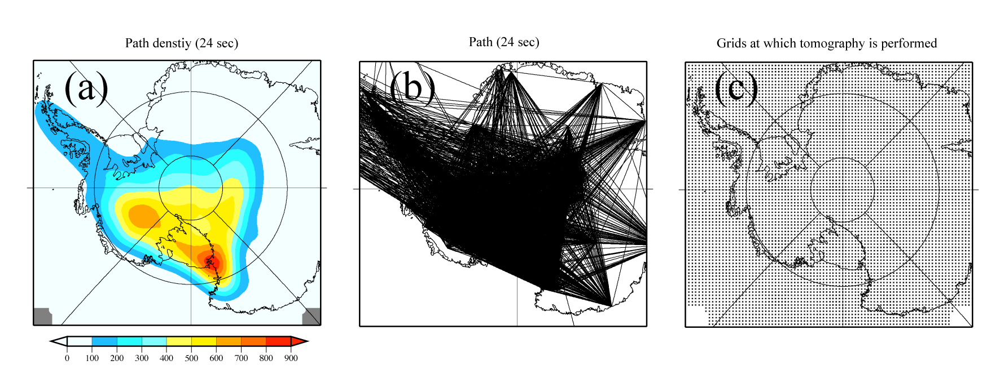

Figure S1. Path density, path distribution, and grid of 24 sec Rayleigh wave ambient noise tomography. Path density is defined as number of path per 2o by 2o cell (~ 40,000 km2).

The horizontal resolution of the resulting 3-D model presented in this study is largely determined by the horizontal resolution of the Rayleigh wave maps. Fig. S2 presents the horizontal resolution for Rayleigh wave maps at different periods derived from the model covariance matrix during the surface wave tomography. In general, the horizontal resolution is ~ 100-200 km for most of the study region.

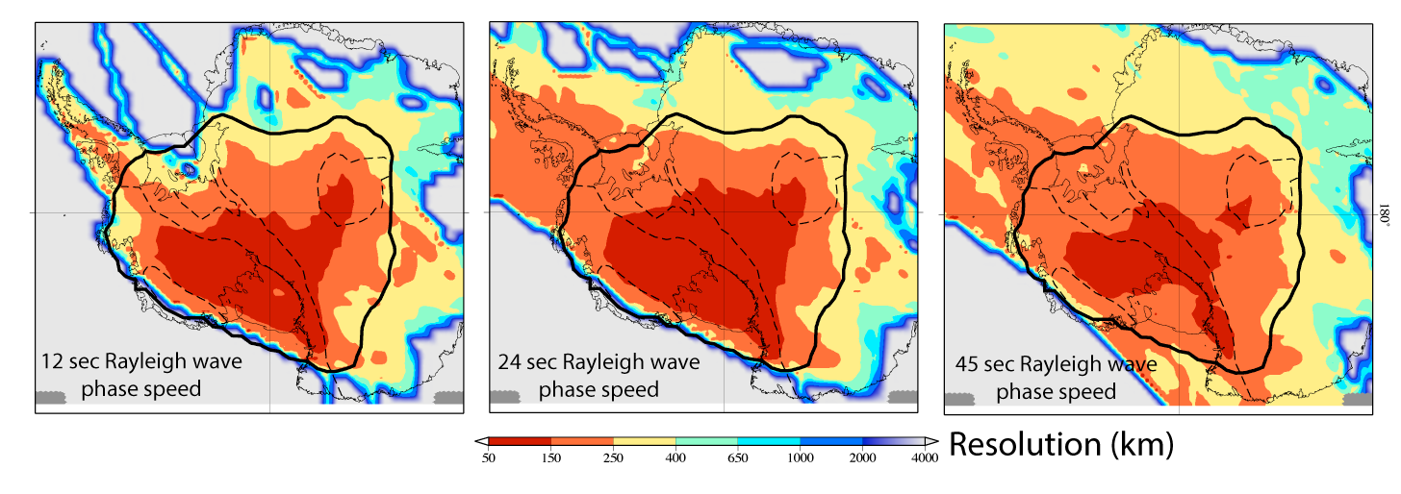

Figure S2. Horizontal resolution of 12, 24, and 45 sec Rayleigh wave phase maps. Solid black contours mark the study region of this paper.



**Figure S3.** Group velocity maps at 12 sec (a), 24 sec (b), 36 sec (c), and 45 (sec).

**Text S2. Depth sensitivity of Rayleigh waves**

The theoretical basis of the surface wave inversion for Vs models is that the speed of propagating Rayleigh wave depends on the local subsurface structure, and that this speed is dispersive. Fig. S4a presents the Vs depth sensitivity of Rayleigh wave phase speeds at four periods (20, 50, 80 and 120 sec). At relatively short periods (~ 20 sec), the phase speed is primarily sensitive to the Vs in the top 40 km, which mainly samples the crust for most of the study region. At periods of 50 and 80 sec, the Rayleigh wave phase speed is principally sensitive to Vs between the 60 and 150 km depth range, which corresponds to the uppermost mantle. At longer periods ~ 120 sec, we obtain peak sensitivity at near 180 km depth. Using the longest period observed in our maps (143 sec), we obtain peak depth sensitivity at >200 km.  Fig. S4a also shows that the sensitivity kernels broaden with period and depth, resulting in limited depth resolution at greater depths (Shen et al., 2013b).

In addition to Vs, Rayleigh waves are also sensitive to local Vp and density structures, but to a lesser degree, at different depth ranges, compared to Vs. Fig. S4b presents the depth sensitivity to Vs, Vp, and density, for a particular period. At 50 s. The Rayleigh wave is positively sensitive to Vs between 60 and 90 km. It is also positively sensitive to Vp in the top 60 km (with a peak at ~10 km), but it is negatively sensitive to density in the top 40 km. The differential sensitivities to Vp and density at shallower depths result in limited resolution manifested as a trade-off between upper mantle Vs and crustal Vp (or, equivalently, Vp/Vs ratio), as well as between upper mantle Vs and crustal density. This trade-off between Vs and Vp/Vs or density is discussed in the supporting information (Lawrence et al., 2006b; Dalton et al., 2008), where we conclude that it does not alter our major findings in the final 3-D model.

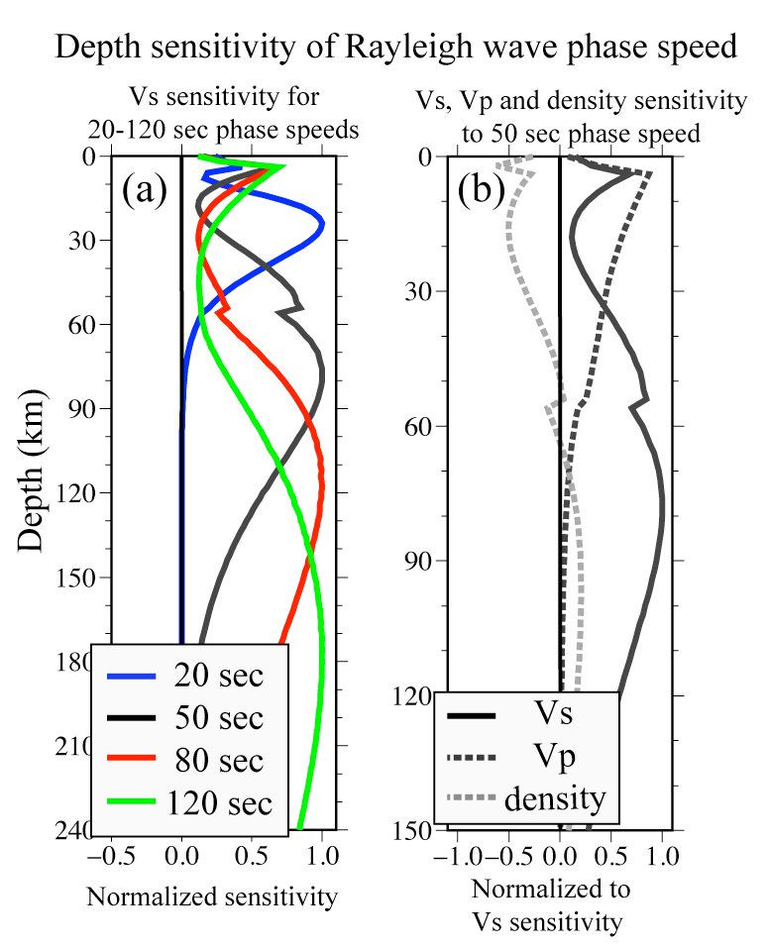

Figure S4. Representative depth sensitivity of Rayleigh wave phase speeds. (a) Depth sensitivity to Vs for 20, 50, 80, and 120 sec periods. (b) Depth sensitivity to Vs, Vp and density for 50 sec period Rayleigh wave. The sensitivity kernel is computed based on the 1-D model shown as the black solid profile in Fig. 16 (b).

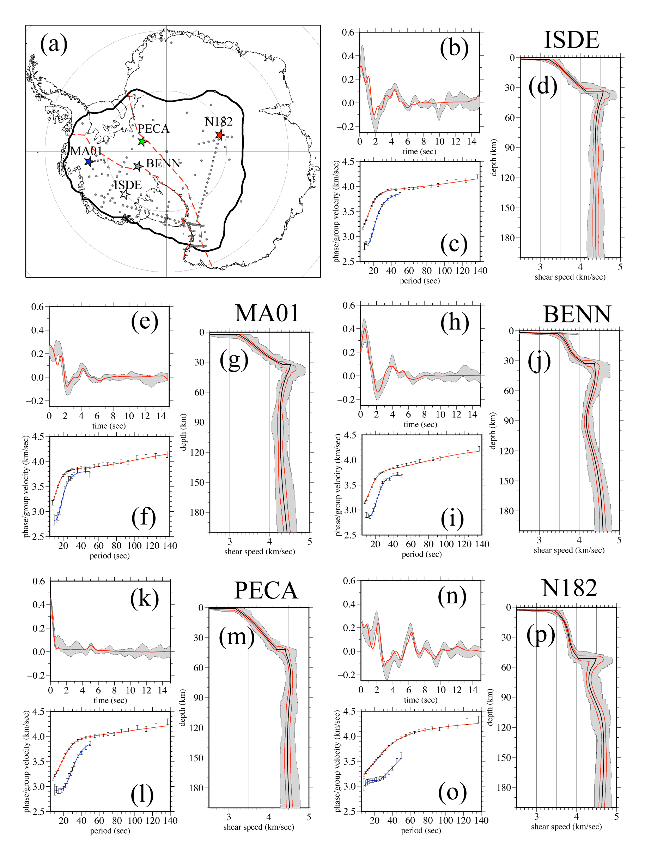

**Figure S5. (a)** Location of the 5 example stations are marked by colored stars: N182 (red), MA01 (blue), PECA (green), ISDE (white), and BENN (grey). (b-d) Observed data (grey areas for PRF, error bars for surface wave dispersion) and fit to data from the models that fit each data the best for station ISDE. All the models expand the gray corridors shown in (d), and the average model derived from the corridor is presented as black line, and 1 standard deviation is shown as two red lines. (e-o): similar as (b-d), but for stations MA01, BENN, PECA, and N182, respectively.

**Text S3. Reliability of the 3D model**

Uncertainties, such as those presented in Fig. 6 of the main paper, quantify the random errors in the final model, while the systematic errors due to false assumptions are not considered in them. However, images of the uppermost mantle shear velocity, (i.e., those presented by Figs. 8 and 9 of the main paper), could be affected by 1) the inaccuracy of the crustal thickness; 2) the assumptions made onto shallow structure through the depth trade-off as discussed in Section 6.4. These assumptions or prior constraints include: Vp/Vs ratio, crustal density, and attenuation structure (Q). In this session, we discuss how different crustal thickness and prior constraints affect the uppermost mantle features shown in Figs. 8 that is discussed in Section 6. We conclude that the effects are too minor to alter our major conclusions.

**S3.1 Effect of Crustal Vp/Vs ratio and Density-Vs Relationship to the Uppermost Mantle Structure**

During the inversion, we assume that the constant crustal Vp/Vs (1.75) and density (2.7 km/sec). These assumptions are in accordance with earlier continental scale tomography (Shen et al., 2013b, Shen and Ritzwoller, 2016, Shen et al., 2016), but may not be completely accurate for Antarctica. Deviation of our assumptions from the real earth’s crustal Vp/Vs and density values could bias the resulting velocity structure. Because the crustal Vp and density have trade-off with uppermost mantle Vs in the depth sensitivity of Rayleigh wave dispersion, we performed extra surface inversion tests to quantify the possible bias.

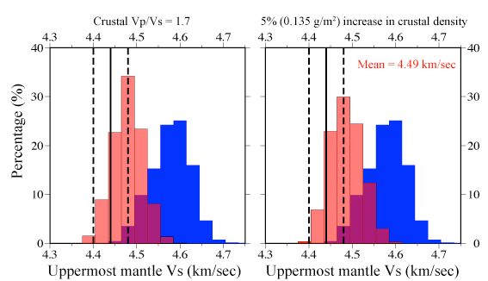

**Figure S6**. Effect to the uppermost mantle Vs beneath GSM from assuming different Vp/Vs and density-Vs relationship. (a) Posterior marginal distribution of uppermost 50 km of mantle Vs for a decreased crustal Vp/Vs (Vp/Vs=1.7, red histogram) and normal Vp/Vs (Vp/Vs=1.75, solid line and two dashed lines). For comparison, the posterior distribution of uppermost mantle Vs beneath a point off the GSM region is shown as blue distribution.

Because crustal Vp has a positive sensitivity kernel to 50 sec Rayleigh wave phase speed, which is mainly sensitive to uppermost mantle Vs, a higher Vp in the crust trades off with slower uppermost mantle. If we lower the Vp/Vs in the prior constraints, the uppermost mantle Vs would increase from the inversion. Fig. S6a presents the effect of decreasing Vp/Vs from 1.75 to 1.7 for a point beneath the GSM. Compared with the inversion with crustal Vp/Vs of 1.7, the new uppermost mantle speed increases slightly from 4.44 km/sec (solid line in Fig. 9a) to 4.48 km/sec (red histogram in Fig. S6a), but the change (0.04 km/sec, ~ 1%) is much smaller than the observed anomaly beneath the GSM (~3% lower than the neighboring area). Similarly, if we assume a much higher crustal density (5% higher than 2.7 g/cm3) beneath the GSM (Fig. S6b), the uppermost mantle Vs will increase slightly (1%) but still cannot explain the anomaly we observed from the data. In summary, although different assumptions of crustal Vp/Vs and density will fluctuate the resulting uppermost mantle Vs, but the level of bias is ~ 1% and any stronger anomaly (>2%) in the uppermost mantle should not be attributed to anomalous crustal Vp/Vs or density and shall be interpreted by its own physical/chemical attributes.

**S3.2 Effect of Q model on the Vs model**

During the shear velocity inversion (both the SW alone and joint inversions), we use a *QS* model (quality factor that quantifies the attenuation) to perform the physical dispersion correction to obtain the final VS model at 1 s period, but a high resolution *QS* model for this region is not available. In this study we set the *QS* to be a constant value of 150 in the upper mantle. Beneath the East Antarctic craton, the uppermost mantle *QS* is different from the value of WANT (Lawrence et al., 2006; Dalton et al., 2008). Tests performed by Shen and Ritzwoller (2016) show that an increase of *QS* from 150 to 300 in the mantle only decreases the mantle Vs by <0.5%, but a decrease of *QS* from 150 to 75 might increase the mantle Vs by up to 1.2%. Along the Transantarctic Mountains and the Marie Byrd Land, the ultra slow speed indicates an increase of attenuation (decreased *QS*) at shallow depths in the mantle. We test the robustness of our results with different attenuation models. Our test shows that, by decreasing *QS* from 150 to 75 in the uppermost 130 km of the mantle, it will increase the uppermost mantle VS by up to ~1%. The effect which is smaller than the standard deviation of the posterior distribution (1.5%) (Fig. S7c). Thus different assumptions of the attenuation model do not significant change the pattern of our resulting images.

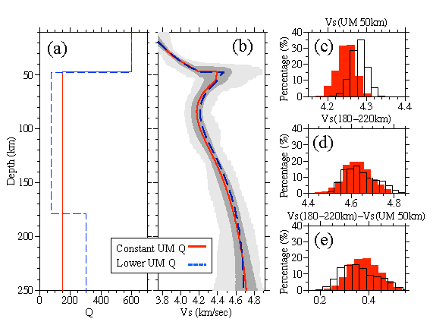

**Figure S7.** Robustness test against different attenuation (*QS*) models.(a) Two different *QS* models. The red solid *QS* model is used to construct the 3D model, which represents a constant *QS* (*QS* =150) in the uppermost mantle. Blue dashed profile is a depth-variant *QS* model in which *QS* at depths < 180 km is 75 and increases to 300 at greater depths. (b) Resulting average model (red line), 1 standard deviation (dark gray corridor), and full model ensemble (light gray corridor) from inversion with constant mantle *QS* model for point A whose location is shown in Sup. Fig. 6a. The average model from inversion with depth variant *QS* model is shown as a blue dashed profile. (c-e) Marginal posterior distributions for three key attributes discussed in the paper from the constant mantle *QS* inversion are shown as red histograms. The posterior distributions for inversion with depth-variant *QS* model are shown as open histograms.

**S3.3 Slow uppermost mantle or an intermediate/slow thick lower crust?**

One speculation is that the slow uppermost mantle Vs beneath the GSM results from a vertical smearing of a possible thick slow lower crust. To test this hypothesis, we perform an inversion with prior constraints so that the crust is be thick (~ 60 km) and lower crustal Vs is smaller than 4.0 km/sec. The prior constraints implement an intermediate/slow lower crust between 40-60 depth range. However, the results shown in Fig. S8 shows that this artificial thick, slower lower crust does not remove uppermost mantle Vs we observed, but a slower uppermost mantle remains at ~ 110 km depth, and a faster Vs at 70 km is seen due to the depth trade-off introduced by a slower lower crust. In conclusion, from this test we observe that 1) a slower crust does not replace the existence of lower Vs in the uppermost mantle; 2) it introduces oscillation in the resulting model due to depth trade-off; 3) a slow upper mantle persists, but is placed at a slightly greater depth. Thus, we conclude that the slower uppermost mantle Vs is not from the vertical smearing effect due to a thick/slow lower crust.



Figure S8. Inversion of surface wave data for a case with thick, slow lower crust. The test point is the same as discussed in S3.1-3.2. Phase and group velocity curves are shown as red and blue curves, respectively, and data are shown as error-bars. The full model range, 1 standard deviation of the posterior distribution, and average model are shown as gray corridor, red profiles, and black profile, respectively.

**S3.4 Fit to data with different Moho depth.**

Fig. 14 in the main manuscript shows that the existence of the slower uppermost mantle beneath the GSM does not depend on different Moho depth. Here in Fig. S9 we display the match to the data for each case shown in Fig. 14. We show that although they are different models (in terms of Moho depth), but they can explain the datasets equally well.



Figure S9. Fit to surface wave dispersion data of different models shown in Fig. 15.



Figure S10. Location (a) of transect GG’ and Vs (b). GG’ is along the transect of GAMSEIS project.

**S4. Covariance, Correlation Coefficients, and Depth Trade-off**

In this part we discuss the depth trade-off between the uppermost mantle (UM) Vs and Vs at different depths. For the uppermost 50 km of the mantle (UM50), its correlation coefficient with the Vs of 120 and 200 km are all less than 0.6 (Fig. S11-S13). Interestingly, as GSM has a thicker crust, its UM Vs is more correlated with the 120km Vs - as it is closer to the 120 km depth (Fig. S11); For the STAM and WARS cases, the UM Vs is in fact less correlated with Vs at 120 km depth; and in all cases the UM Vs has very weak correlation with 200 km Vs. One thing notable is that in the paper, we are mostly discussing Vs at some depth range (e.g., uppermost 50 km of the mantle, Vs between 60 and 100 km). This depth-averaged Vs value has already minimized some depth trade-off: if we are discussing Vs at 80 km depth, it'll have a strong trade-off with Vs at 60 or 100 km.



**Figure S11.** Variance, correlation coefficients, and depth trade off measured by the MCMC inversion. (a) Covariance matrix for Vs at different depths for a Monte Carlo inversion of a point in GSM. The location of the point is marked in the main manuscript Fig. 13a. The chosen depths at which statistics of Vs are computed are: 10 km, 20 km, 40 km, 60 km, 80 km, 120 km, 160 km, 200 km, and uppermost 50 km of the mantle (UM50). (b) Correlation coefficients between Vs at these depths. (c) distribution of the UM50 Vs and Vs at 120/200 km. The distribution shows that the correlation between UM50 Vs and Vs at greater depths is weak.



Figure S12. Similar for Fig. S11, but for a point near the STAMs.



Figure S13. Similar to Fig. S11, but for a location near the WARS.